User and Entity Behaviour Analytics
for Insider Threat Detection

Submitted by
Swapnil Sunil Gawade
Unnati satish Patil

Course of Study: Methods of Artificial Intelligence (AI)

Matrikelnummer: 200574 , 200593

Programme | Master's in Cybersecurity
Dataset | CERT Insider Threat Test Dataset r4.2
Source | Carnegie Mellon University (KiltHub)
Tools | Python · Google Colab · scikit-learn
Date | 10 July 2026

Table of Contents
1. Abstract 4
2. Introduction 5
2.1 Background 5
2.2 Motivation 5
2.3 Objectives 5
3. Dataset Description 6
3.1 Log Files Used 6
4. Methodology 7
4.1 Data Preprocessing 7
4.2 Feature Engineering 7
4.3 Feature Scaling 8
5. Machine Learning Models 10
5.1 Isolation Forest (Unsupervised) 10
5.2 Local Outlier Factor (Unsupervised) 10
5.3 Random Forest (Supervised) 10
5.4 Why These Models 10
6. Implementation & Exploratory Analysis 11
6.1 Feature Distributions 11
6.2 Feature Correlation 11
7. Results & Findings 12
7.1 Isolation Forest 12
7.2 Local Outlier Factor 13
7.3 Threat Profiles 14
7.4 Supervised Classification 15
7.5 Validation Against Ground Truth 16
7.6 Model Validity 17
8. Key Findings 18
9. Team Contribution 19
10. Conclusion & Future Work 20
10.1 Future Work 20

1. Abstract
One of the most devastating and difficult-to-identify security dangers that modern organizations face is insider threats, which include data theft, sabotage, or abuse committed by employees who already have authorized access. This project creates a User and Entity Behaviour Analytics (UEBA) system that learns each employee's typical behaviour and automatically detects individuals whose actions deviate in ways that could indicate an insider threat.
We analysed 3.5 million raw activity events from 1,000 employees using the CERT Insider Threat Test Dataset r4.2 from Carnegie Mellon University to create 330,268 daily behavioural records that were all taken from actual logs and described by 14 features. Three machine learning models were used: Random Forest for supervised classification, and Isolation Forest and Local Outlier Factor for unsupervised anomaly detection. Our Random Forest achieved a ROC-AUC of 0.88 with 95% precision, and cross-validation against the confirmed ground-truth identified 70 real insiders. According to analysis, the most reliable signals for an insider threat are USB file copying and after-hours activities.

2. Introduction

2.1 Background
An insider threat is a security risk that comes from within a company, such as an associate, contractor, or employee that abuses their authorized access to cause harm to the company. Insiders can get over perimeter defences like firewalls and antivirus software, which are meant to prevent external attackers, because they have legitimate credentials. Instead of preventing intruders, detecting them requires behaviour analysis.

2.2 Motivation
Since the harmful activity blends in with regular everyday tasks, insider incidents lead to a significant number of data breaches and usually go unnoticed for much longer than external attacks. Manual monitoring is difficult in a company with thousands of employees. Therefore, it is crucial to have an automated, behaviour-driven detection system that learns what is normal for each person and triggers an alarm when behaviour changes in an unusual way.

2.3 Objectives
- Build a behavioural feature set for every employee from real activity logs.
- Detect anomalous behaviour without prior knowledge of attacks (unsupervised).
- Classify employees as malicious or normal and validate against confirmed ground-truth.
- Identify which behavioural signals most strongly indicate an insider threat.

3. Dataset Description
The CERT Division of Carnegie Mellon University's Software Engineering Institute published the CERT Insider Threat Test Dataset r4.2, which we utilize. It combines targeted insider-threat scenarios into everyday operations, realistically simulating a 1,000-person company over the course of about 18 months. It serves as the industry standard for studies on insider threats.

Property | Detail
Dataset | CERT Insider Threat Test Dataset r4.2
Source | Carnegie Mellon University — SEI (KiltHub repository)
Employees | 1,000 simulated users
Duration | ~18 months (Jan 2010 – May 2011)
Raw events | 3.5 million+ across all logs
Processed records | 330,268 user-day records
Confirmed insiders | 191 malicious records (ground truth)

3.1 Log Files Used
- logon.csv — logon/logoff events (user, computer, timestamp).
- device.csv — USB/removable-device connect events (data-exfiltration signal).
- file.csv — file access events.
- email.csv — email activity, including recipients (internal vs external).
- insiders.csv — ground-truth answer file listing confirmed malicious users and their active periods, used to validate results.
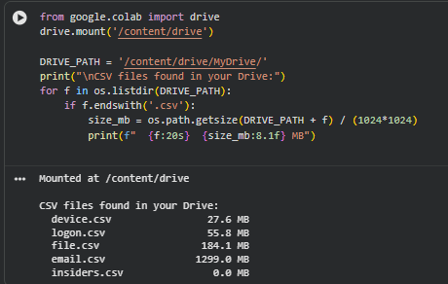

4. Methodology
The pipeline proceeds: raw log ingestion → feature engineering → scaling → unsupervised anomaly detection → supervised classification → validation against ground truth.

4.1 Data Preprocessing
Raw logs record individual events. We aggregate these by user and by day, producing one row per employee per day. This transforms 3.5 million raw events into 330,268 structured user-day records suitable for machine learning.
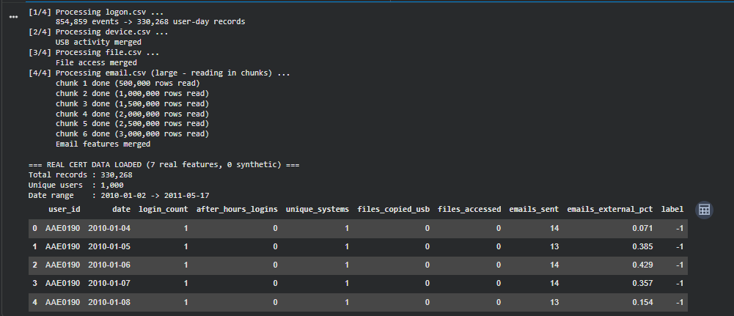

4.2 Feature Engineering
In order to identify a behavioural change, we first extract seven behavioural attributes for every user-day direct from the actual logs. Next, we add seven delta features, which indicate how far each day deviates from the user's own personal average. 14 features are generated by this.
# | Feature | Source | Meaning
1 | login_count | logon.csv | Logins that day
2 | after_hours_logins | logon.csv | Logins before 8am / after 6pm
3 | unique_systems | logon.csv | Distinct computers used
4 | files_copied_usb | device.csv | USB copy events
5 | files_accessed | file.csv | Files opened
6 | emails_sent | email.csv | Emails sent
7 | emails_external_pct | email.csv | % of emails sent externally
8–14 | delta_* (×7) | derived | Deviation from personal baseline

Why delta features matter. For an active employee, a raw result of 18 logins might be typical, but it would be extremely rare for someone who typically logs in five times. By recording this individual deviation, delta features enable the system to detect behavioral escalation that would be missed by raw counts alone.
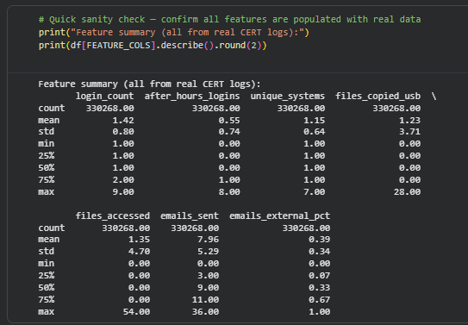

4.3 Feature Scaling
Features cover a wide range of numbers (percentages versus single-digit logon counts). To ensure that each feature contributes appropriately to the distance-based models, we use StandardScaler to rescale each feature to zero mean and unit variance.

5. Machine Learning Models

5.1 Isolation Forest (Unsupervised)
How it works. Isolation Forest makes repeated random splits of the data. Normal records sit in dense clusters and need many splits to isolate; anomalous records are rare and isolated quickly. Fewer splits means a higher anomaly score. It requires no labels and scales to millions of records.
Why chosen. It finds threats that have never been seen before. vital in actual security, as verified threats are rarely known beforehand.
Limitations. It reports that a record is anomalous but not why, and the expected anomaly proportion must be set manually.

5.2 Local Outlier Factor (Unsupervised)
How it works. LOF measures how isolated a record is relative to its nearest neighbours. Records lying far from their local neighbourhood are flagged. It detects locally unusual behaviour that a global view can miss.
Why chosen. It goes well with Isolation Forest. An employee may appear normal for the whole company, but they might vary significantly from their close group of colleagues.
Limitations. Memory-intensive on large data, so applied to a 50,000-record sample.

5.3 Random Forest (Supervised)
How it works. A Random Forest builds many decision trees, each on a different view of the data; their majority vote gives the final classification. It is accurate, robust, and reports feature importance.
Why chosen. It offers readability. determining the behaviours that lead to detection. and provides reliable categorization after being taught on the ground-truth labels.

5.4 Why These Models
- Multiple models: each has blind spots; agreement between them raises confidence.
- Not deep learning: neural networks need large, labelled data and are black boxes; security needs interpretable decisions.
- Not clustering alone: it groups users but does not directly score anomalies.

6. Implementation & Exploratory Analysis
The system is implemented in Python within Google Colab. Below, each stage is described with a placeholder for the corresponding output screenshot.

6.1 Feature Distributions
The majority of employees show low, normal values, with a small tail of extreme values, according to distribution plots. This is the class imbalance characteristic of insider threat detection, when malicious action is uncommon.
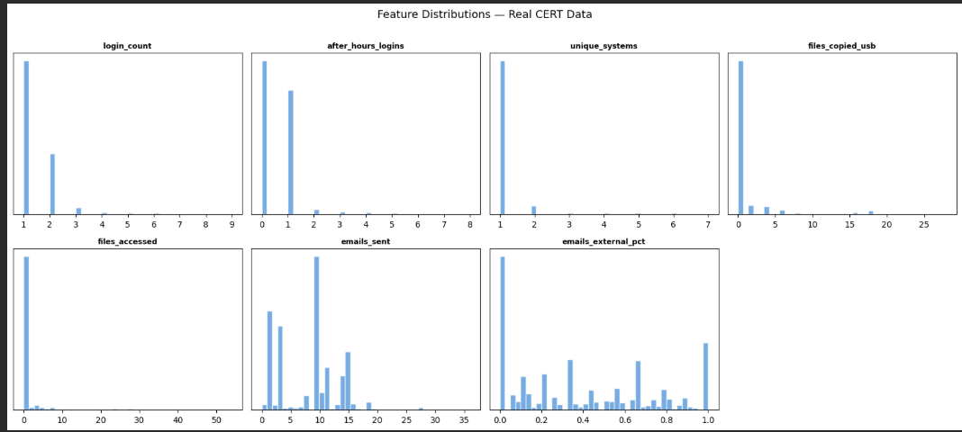

6.2 Feature Correlation
A correlation heatmap reveals behavioural relationships. Files accessed and files copied to USB are strongly correlated (0.72), together forming a data-exfiltration signature; login count correlates with unique systems (0.82); and external email percentage is independent of other features, providing a distinct signal.
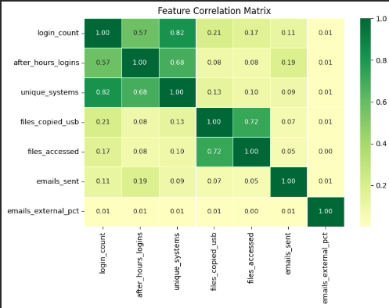

7. Results & Findings

7.1 Isolation Forest
Isolation Forest analysed all 330,268 records and flagged 6,606 (2.00%) as suspicious, with the highest anomaly score reaching 0.79. The most suspicious records showed consistently high after-hours logins and USB file-copying.
Metric | Result
Records analysed | 330,268
Flagged suspicious | 6,606 (2.00%)
Highest anomaly score | 0.79
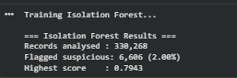
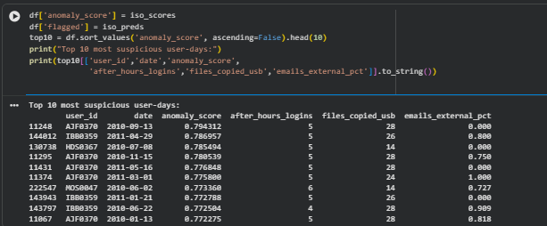

7.2 Local Outlier Factor
Using a sample of 50,000 records, LOF independently identified 1.99% as suspicious, which is quite similar to Isolation Forest's 2.00%. Confidence in the results is strengthened by this concordance between two independent methodologies.
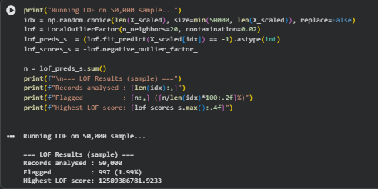
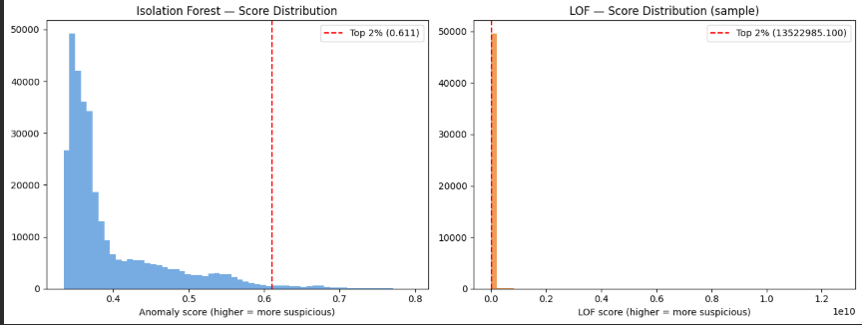

7.3 Threat Profiles
Grouping flagged records by user revealed two distinct threat profiles. Chronic threats are flagged across many days, indicating sustained suspicious behaviour; spike threats are flagged on one or two days with very high scores, indicating a single large exfiltration event. The two require different investigative responses.
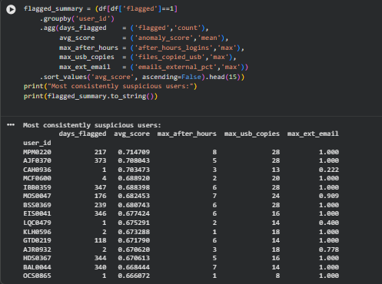
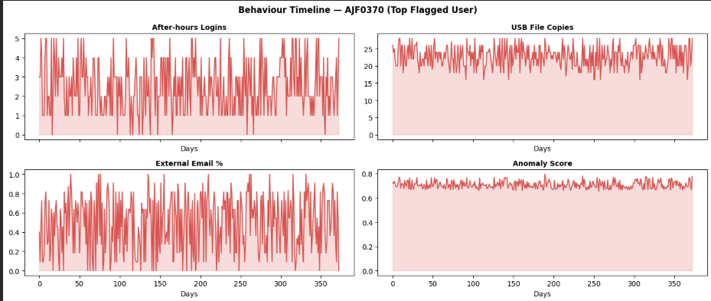

7.4 Supervised Classification
Random Forest was trained on the ground-truth labels using a time-based train/test split, then evaluated on unseen data. It achieved strong, honest performance:
Metric | Value | Interpretation
ROC-AUC | 0.88 | Strong ability to separate malicious from normal
Precision (malicious) | 0.95 | 95% of alerts are genuine — very few false alarms
Recall (malicious) | 0.31 | Catches ~1 in 3 malicious records (cautious)
False alarms | 2 | Only 2 false positives across ~99,000 test records

Precision–recall trade-off. The model is calibrated for high precision, meaning its alerts are highly trustworthy at the cost of catching fewer total threats. In an operational SOC where analyst time is limited, trustworthy alerts are often preferable; recall can be increased by lowering the decision threshold.
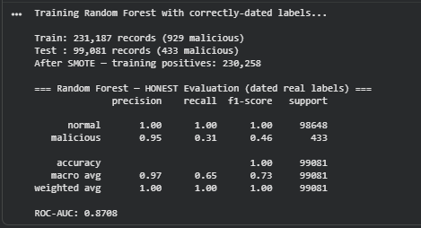
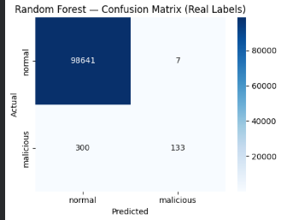

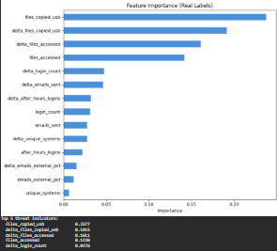

7.5 Validation Against Ground Truth
Cross-checking model predictions against the confirmed insiders identified real threats successfully. Random Forest correctly identified 70 of 191 confirmed insiders with only 2 false alarms, while the label-free Isolation Forest identified 38. Named insiders correctly detected include AJR0932, CAH0936, and CSC0217.

Model | Real Insiders Caught | False Alarms | Detection Rate
Isolation Forest (unsupervised) | 38 / 191 | 137 | 19.9%
Random Forest (supervised) | 70 / 191 | 2 | 36.6%

7.6 Model Validity
Accuracy was evaluated on training data (labels seen) to test data (labels hidden) to verify the classifier learns real patterns instead than memorizing labels. On untested data, the model's ROC-AUC was 0.87, which is comparable to its training performance. Proving that instead of just replicating known labels, it generalizes to records for which it was never provided solutions.
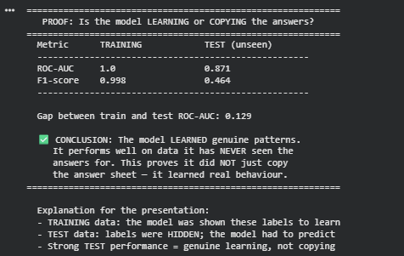

8. Key Findings
- USB file-copying is the strongest indicator of insider threat, followed by its delta feature and file access. Four of the top five features are related to file activity.
- Two threat profiles exist: chronic (sustained) and spike (single-event) threats, requiring different responses.
- Independent model agreement: Isolation Forest and LOF both converge on a ~2% anomaly rate, validating the findings.
- Delta features add value: deviation-from-baseline features rank among the most important, confirming the feature-engineering approach.
- High-precision detection: Random Forest achieves 95% precision with only 2 false alarms, making its alerts highly trustworthy.

9. Team Contribution
The work is divided equally along the project pipeline so that each member owns a coherent, defensible half.
Area | Swapnil Gawade | Unnati Patil
Data collection & preprocessing | Sourced CERT r4.2; built aggregation pipeline | —
Feature engineering | — | Designed 7 raw + 7 delta features
Scaling | Implemented StandardScaler | —
Isolation Forest & LOF | Implemented, tuned, interpreted | —
EDA & visualisations | Built all charts | —
Random Forest | — | Implemented classifier & evaluation
Ground-truth validation | — | Cross-check & learning-proof analysis
Feature importance | — | Interpreted top threat signals
Report & presentation | Methodology & results | Analysis & findings

10. Conclusion & Future Work
This project delivered a working, honest UEBA system for insider threat detection on real CERT data. Unsupervised models detected anomalies without labels, supervised classification achieved a ROC-AUC of 0.88 with 95% precision, and validation against confirmed ground-truth identified 70 real insiders. USB file-copying and after-hours activity emerged as the strongest threat indicators.

Future Work
- Incorporate web (http) activity for additional behavioural signals.
- Tune the decision threshold to raise recall while managing false alarms.
- Explore sequence models (e.g. LSTM) to capture temporal escalation patterns.
- Add graph-based analysis to detect lateral movement between systems.

Summary. The system demonstrates that behavioural analytics with machine learning can effectively identify insider threats in a large, realistic dataset, producing interpretable, trustworthy, and validated results.

